**Data Analysis on Kalboard 360’s Dataset**

**Introduction**

In the field of education technology, Kalboard 360 stands out as a multi-agent Learning Management System (LMS), using advanced technology to offer synchronized access to educational resources. The dataset, sourced from Kalboard 360 via the Experience API (xAPI), consists of 480 student records and 16 features, covering demographics, academic background, and behavior.

The student group is diverse, representing various countries, creating a rich cultural mix. The dataset spans two semesters and includes attendance data, categorizing students by absence days. Notably, there's a Parent Participation category, with sub-features like Parent Answering Survey and Parent School Satisfaction.

This report employs Python and Power BI for data analysis, KPI creation, and dashboard design. The main objective is to uncover insights that can inform decisions for enhancing engagement on the Kalboard 360 platform.

**Key Insights**

Nationalities and Birthplaces: Students from diverse backgrounds create a multicultural environment.

Stages and Grades: Education spans lower, middle, and high school, with grades G-02 to G-12.

Sections: Students are categorized into A, B, and C, offering academic diversity.

Behavioural Patterns:

Topic Engagement: Diverse academic interests revealed through topics like IT, Math, Arabic, Science, etc.

Semester Analysis: Performance tracked across two semesters (F and S) for academic trend exploration.

Parental Involvement:

Survey Participation: Active parental engagement through surveys.

Satisfaction: Significant parental satisfaction indicates a positive community sentiment.

Numerical Overview:

Raised Hands: Average of approximately 46.78, reflecting diverse distribution.

Visited Resources: Students access an average of around 54.80 resources, showing robust engagement.

Announcements and Discussions: Average views for announcements (37.92) and discussion participation (43.28) highlight interactive engagement.

Categorical Summary:

Relation and Absence Days: Students identify as fathers or mothers, and absence days categorized as under 7 or above 7, offering insights into familial and attendance dynamics.

The bar chart illustrates student distribution across academic levels—High (H), Medium (M), and Low (L). Notably, there are over 125 students in the High level, 200 in the Medium level, and an additional 125 in the Low level. This highlights the platform's capacity to accommodate a diverse range of academic proficiencies.

Box plots depicting engagement metrics—hand raises, discussion participation, resource views, and announcement views—reveal a clear trend. High-level students consistently exhibit superior engagement, while medium-level students demonstrate moderate engagement, and low-level students show comparatively lower involvement. These findings underscore a positive correlation between academic level and platform engagement, suggesting opportunities for targeted interventions to enhance participation among medium and low-level students.

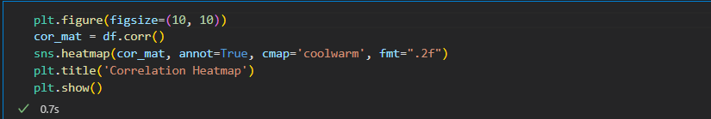

Strong Positive Correlations:

Raised Hands and Visited Resources: A robust correlation of about 0.69 shows that students who often raise hands are actively involved in resource exploration.

Announcements View and Visited Resources: A correlation of around 0.59 indicates that students actively viewing announcements also engage with educational resources.

Categorical Features:

Parental Engagement: Positive correlations are observed between various engagement metrics and features such as 'ParentAnsweringSurvey_Yes' and 'ParentschoolSatisfaction_Good.'

Student Absence Days: The metric 'StudentAbsenceDays_Under-7' positively correlates with various engagement metrics, suggesting that students with fewer absence days tend to be more engaged.

**Key Performance Indicators**

1. Class
2. Raisedhands
3. VisITedResources
4. AnnouncementsView
5. Discussion
6. StageID
7. Semester
8. Topic
9. ParentAnsweringSurvey
10. StudentAbsenceDays
11. ParentschoolSatisfaction

**Dashboard**

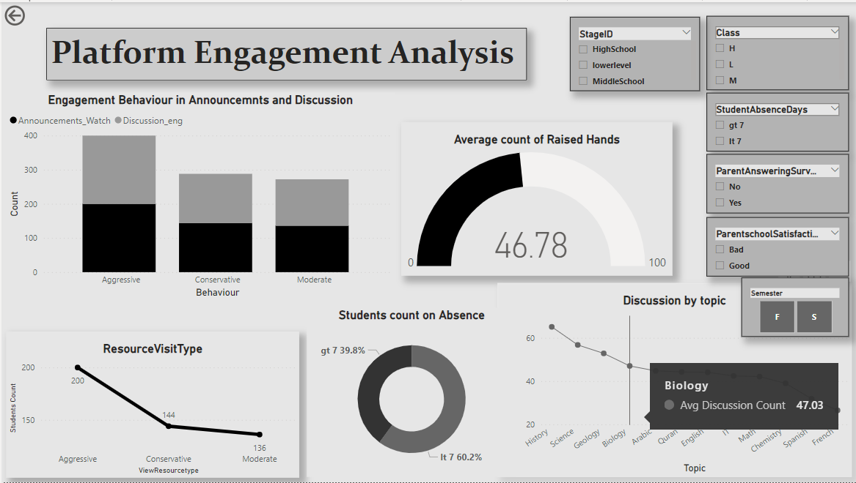

Link: <https://github.com/Farzinaayub/edplatform-engagement-analysis-.git>

Prepared By: Farzeena P A